**Data analyst portfolio project**

**Part 1**

**MS SQL Server**

Import raw data to MYSQL serer

Writing queries as per problem statement given by client

Create report

**Part 2**

Connect MS SQL Server to power bi

Data cleaning

Data processing using DAX functions to get custom columns and conditional columns

Data visualization- building charts, use advance functionality to format charts

Build dynamic dashboard (first)

Build sales dashboard (second)

**PROBLEM STATEMENT in 2 section**

**1st section- KPI's REQUIREMENT**

We need to analyze key indicators for our pizza sales data to gain insights into our business performance. Specifically, we want to calculate the following metrics:

1. Total Revenue: The sum of the total price of all pizza orders.

2. Average Order Value: The average amount spent per order, calculated by dividing the total revenue by the total number of orders.

3. Total Pizzas Sold: The sum of the quantities of all pizzas sold.

4. Total Orders: The total number of orders placed.

5. Average Pizzas Per Order: The average number of pizzas sold per order, calculated by dividing the total number of pizzas sold by the total number of orders.

﻿

**PROBLEM STATEMENT**

**Section 2- CHARTS REQUIREMENT**

We would like to visualize various aspects of our pizza sales data to gain insights and understand key trends. We have identified the following requirements for creating charts:

*1.Daily Trend for Total Orders:*

Create a bar chart that displays the daily trend of total orders over a specific time period. This chart will

help us identify any patterns or fluctuations in order volumes on a daily basis.

*2.Monthly Trend for Total Orders:*

Create a line chart that illustrates the hourly trend of total orders throughout the day. This chart will allow us to identify peak hours or periods of high order activity.

*3.Percentage of Sales by Pizza Category:*

Create a pie chart that shows the distribution of sales across different pizza categories. This chart will provide insights into the popularity of various pizza categories and their contribution to overall sales.

﻿

*4.Percentage of Sales by Pizza Size:*

Generate a pie chart that represents the percentage of sales attributed to different pizza sizes. This

chart will help us understand customer preferences for pizza sizes and their impact on sales.

*5.Total Pizzas Sold by Pizza Category:*

Create a funnel chart that presents the total number of pizzas sold for each pizza category. This chart

will allow us to compare the sales performance of different pizza categories.

*6.Top 5 Best Sellers by Revenue, Total Quantity and Total Orders*

Create a bar chart highlighting the top 5 best-selling pizzas based on the Revenue, Total Quantity, Total Orders. This chart will help us identify the most popular pizza options.

*7. Bottom 5 Best Sellers by Revenue, Total Quantity and Total Orders*

Create a bar chart showcasing the bottom 5 worst-selling pizzas based on the Revenue, Total Quantity, Total Orders. This chart will enable us to identify underperforming or less popular pizza options.

﻿

SOFTWARE USED

MS OFFICE/ EXCEL: VERSION 2021

MS SQL SERVER: 19.0

SQL SERVER MANAGEMENT STUDIO - 19.0.20209.0

POWER BI: JUNE 2023 Version

1. I created database named Pizza DB in MS SQL server
2. Added flat file (CSV file) named ‘pizza sales’.
3. Now firing queries as required in problem statement 1.

**PIZZA SALES SQL QUERIES**

**A. KPI**

**1. Total Revenue:**

select SUM(total_price) as Total_Revenue from pizza_sales

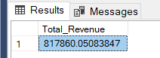

**2. Average Order Value:**

select SUM(total_price) as Total_Revenue from pizza_sales

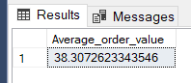

**3.Total pizzas sold:**

select SUM(quantity) as total_pizza_sold from pizza_sales

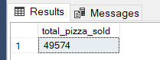

**4. Total Orders:**

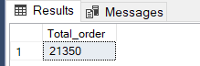

**5.Average pizza per order:**

select cast(sum(quantity) as decimal (10,2)) /

cast(count (distinct order_id) as decimal (10,2)) as avg_pizza_per_order from pizza_sales

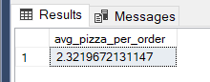

Chart requirements

***Daily Trend for Total Orders:***

select DATENAME(dw, order_date) as order_day, count(distinct order_id) as Total_orders from pizza_sales

group by DATENAME(dw, order_date)

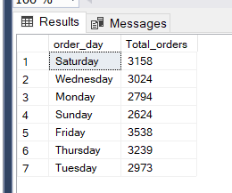

***Monthly Trend for Total Orders:***

select DATENAME(Month, order_date) as Month_name, count(distinct order_id) as Total_orders from pizza_sales

group by DATENAME(month, order_date)

order by Total_orders Desc

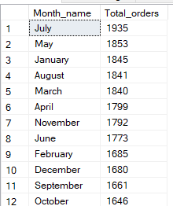

***Percentage of Sales by Pizza Category:***

select pizza_category, sum(total_price) as total_sales, sum(total_price) * 100/

(select sum(total_price) from pizza_sales) as PCT from pizza_sales

where month(order_date)=1

group by pizza_category

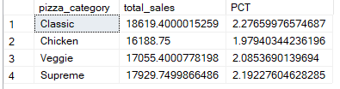

***Percentage of Sales by Pizza Size:***

select pizza_size, sum(total_price) as total_sales, sum(total_price) * 100/

(select sum(total_price) from pizza_sales) as PCT from pizza_sales

where month(order_date)=1

group by pizza_size

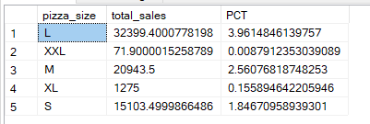

***6.Top 5 Best Sellers by Revenue, Total Quantity and Total Orders***

*Top 5 based on REVENUE-*

select top 5 pizza_name, sum(total_price) as Total_revenue from pizza_sales group by pizza_name order by Total_revenue Desc

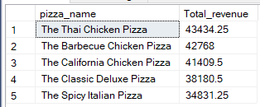

*Top 5- based on - TOTAL QUANTITY-*

select top 5 pizza_name, sum(Quantity) as Total_quantity from pizza_sales group by pizza_name order by Total_quantity Desc

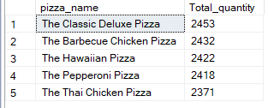

*Top 5- based on TOTAL ORDERS-*

select top 5 pizza_name, count(distinct order_id) as Total_orders from pizza_sales group by pizza_name order by total_orders Desc

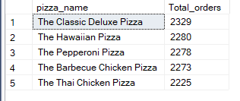

***7. Bottom 5 Best Sellers by Revenue, Total Quantity and c***

*Bottom 5 based on- Total Quantity*

select top 5 pizza_name, sum(quantity) as Total_quantity from pizza_sales group by pizza_name order by Total_quantity asc

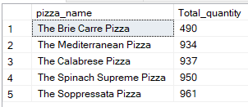

*Bottom 5 based on- Revenue*

select top 5 pizza_name, sum(total_price) as Total_revenue from pizza_sales group by pizza_name order by Total_revenue asc

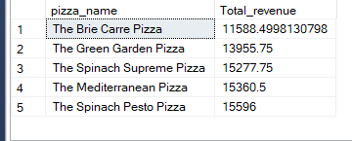

*Bottom 5 based on-Total Orders*

select top 5 pizza_name, count(distinct order_id) as Total_orders from pizza_sales group by pizza_name order by total_orders asc

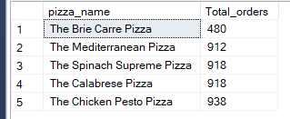

**NOTE**

If you want to apply the Month, Quarter, Week filters to the above queries you can use WHERE clause. Follow some of below examples

SELECT DATENAME(DW, order_date) As order_day, COUNT (DISTINCT order_id) AS total_orders  
FROM pizza_sales  
WHERE MONTH(order_date) = 1  
GROUP BY DATENAME (DW, order_date)

*Here MONTH(order date) = 1 indicates that the output is for the month of January. MONTH(order date) = 4 indicates output for Month of April.

SELECT DATENAME (DW, order_date) AS order_day, COUNT (DISTINCT order_id) AS total_orders  
FROM pizza_sales  
WHERE DATEPART(QUARTER, order_date)=1

GROUP BY DATENAME (DW, order_date)

*Here DATEPART(QUARTER, order_date) = 1 indicates that the output is for the Quarter 1. MONTH(order_date) = 3 indicates output for Quarter 3.